TIROL-KIT adapter Tapered Stretcher  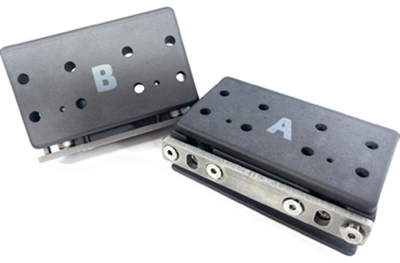 |  | PRODUCT INFO  - F2500082  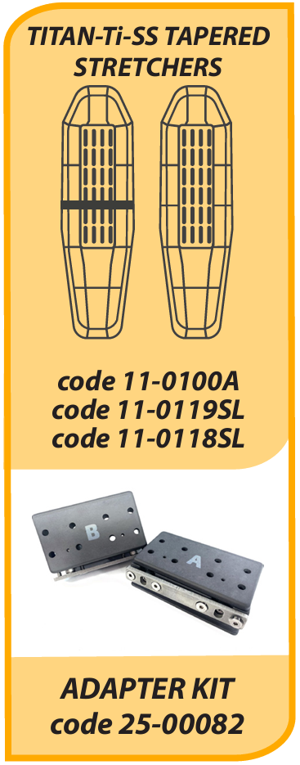

TIROL-KIT adapter Tapered Stretcher
The Tirol Kit is used in combination with the Titan stretchers.
Depending on your stretcher type, regular or tapered you can make it compatible with the Tirol Kit

